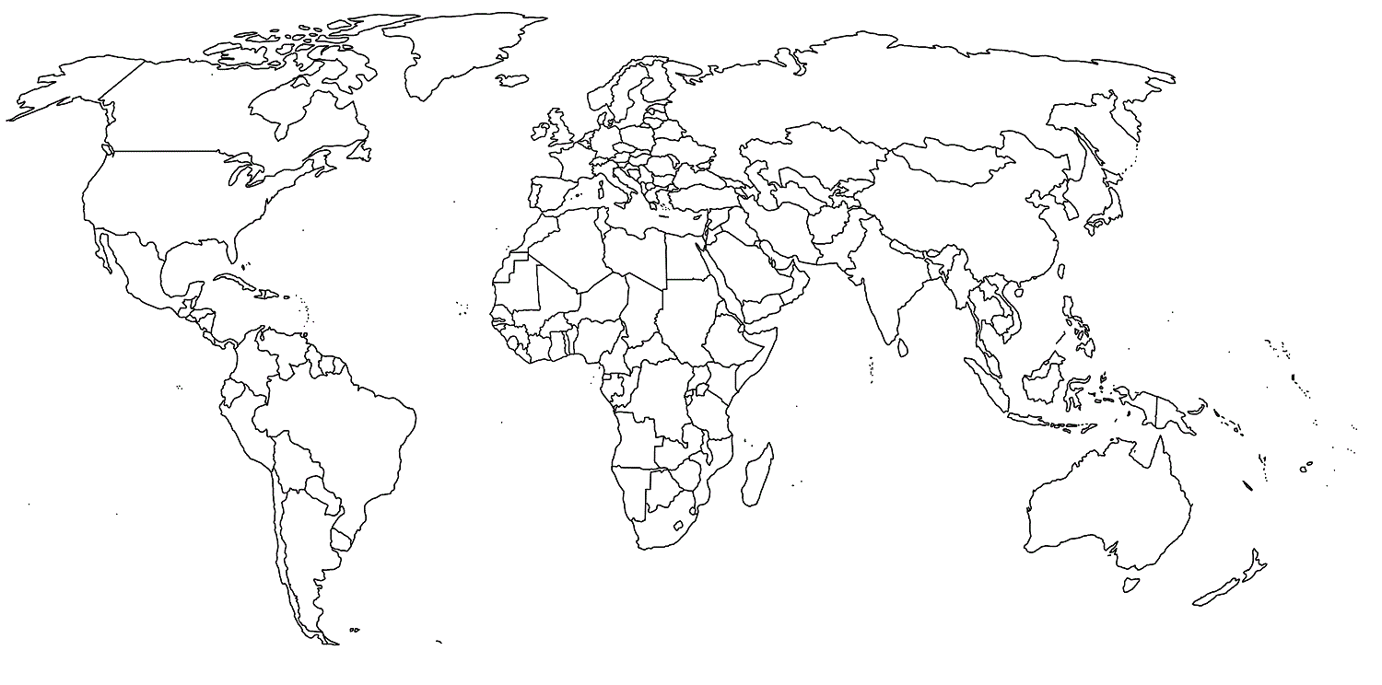
World Religions Map
Legend:
Name: ____________________________________

