Art in The Renaissance Name: __________________________________
Characteristics | Painting One - Description | Painting Two - Description
Characteristic One :
Characteristic Two :
Characteristic Three:
Time Period?

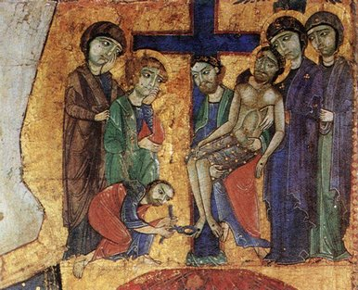
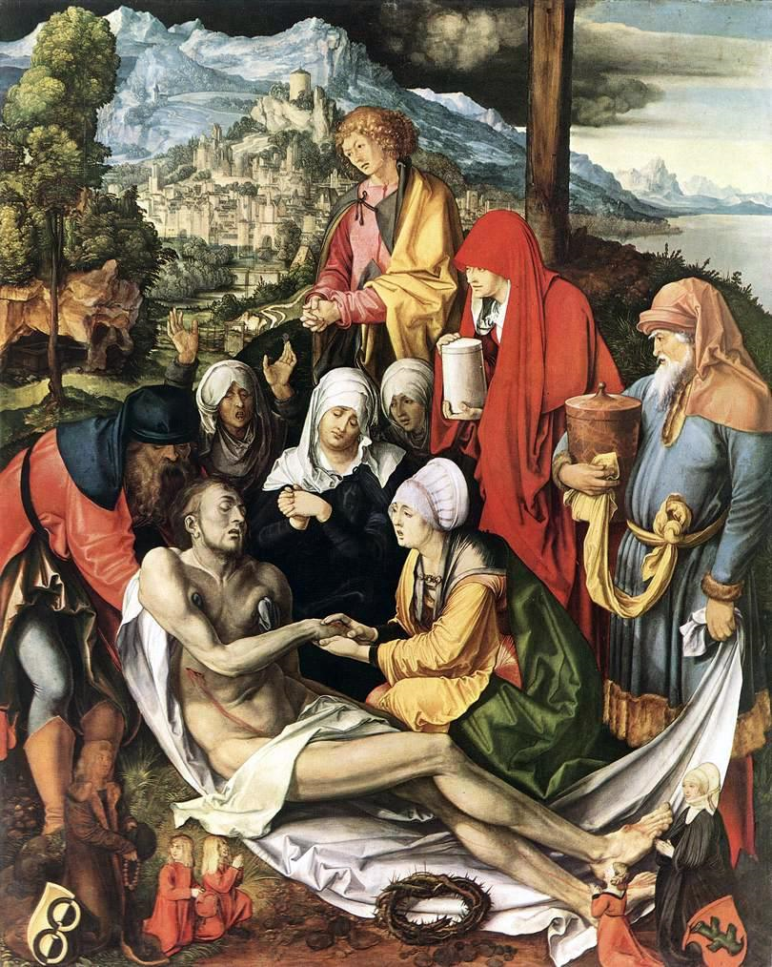
1 2

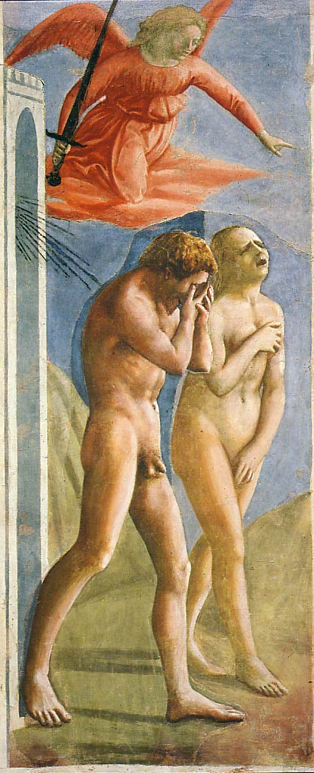
New Techniques:

Characteristics of Renaissance Art:
Circle the facial expressions

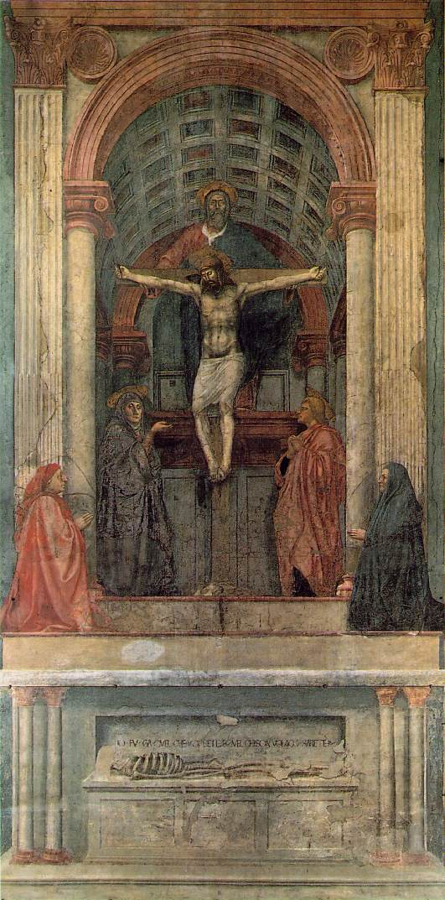

Draw the linear perspective on the image.
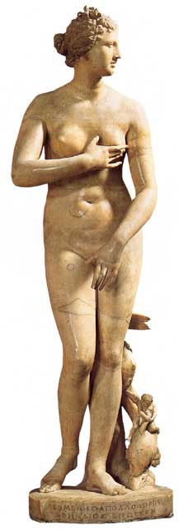

.

Outline the s-curve on the image

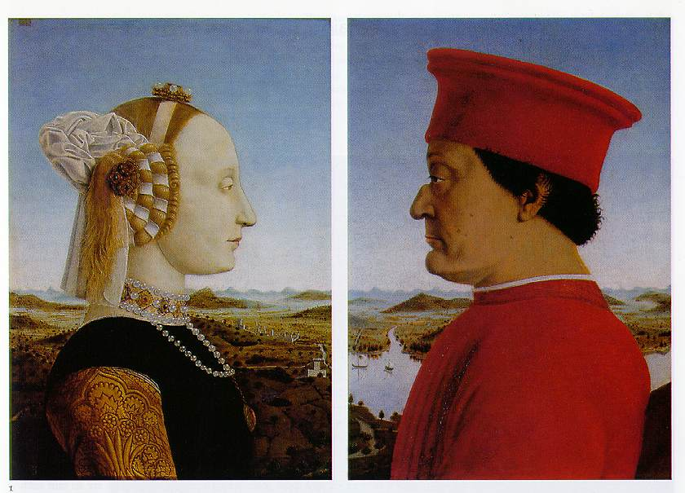
Circle the individual features of the figures.

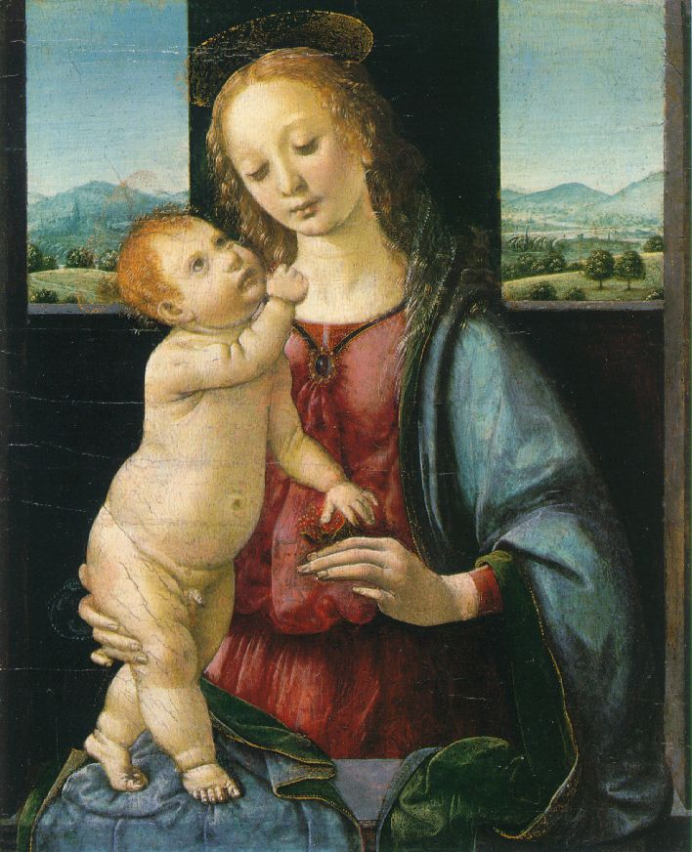

Draw the triangles on the image.

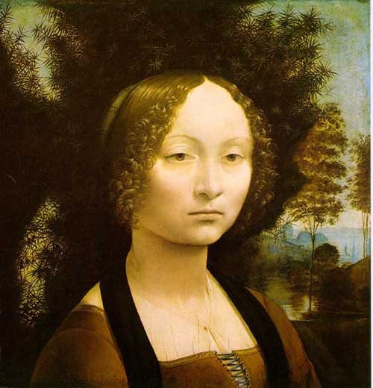

Label where the chiaroscuro and sfumato occur on the image.

Artists and works to remember:

