|  |
| --- |
| **Legend** |

**Geography of the World**

**Name: ______________________________**

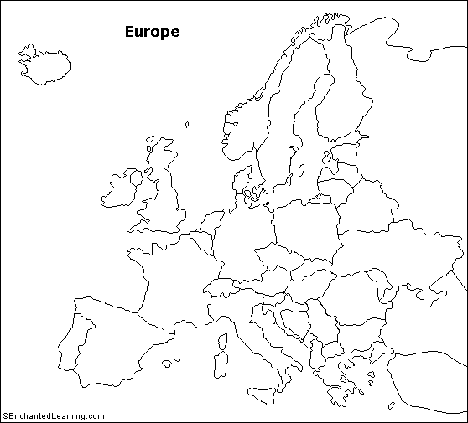

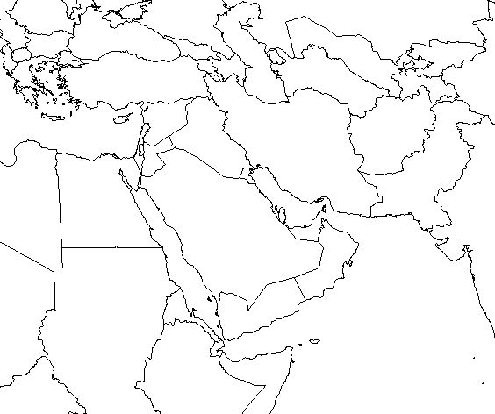**Middle East /**

**Persian Gulf**

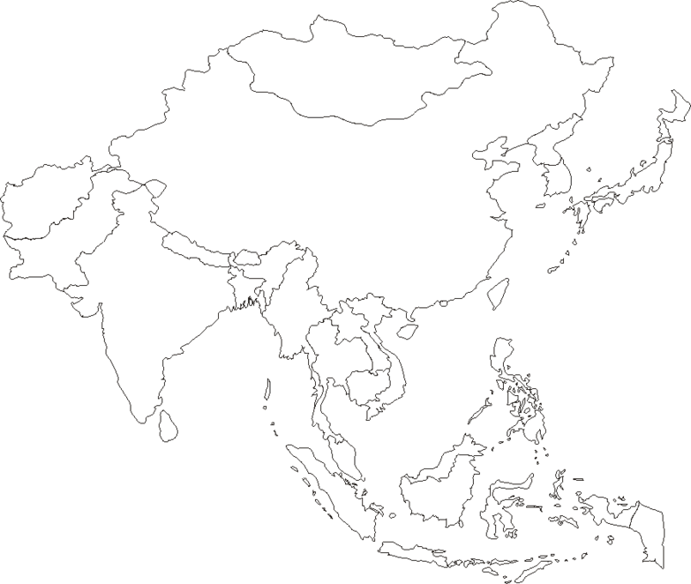

**Asia**

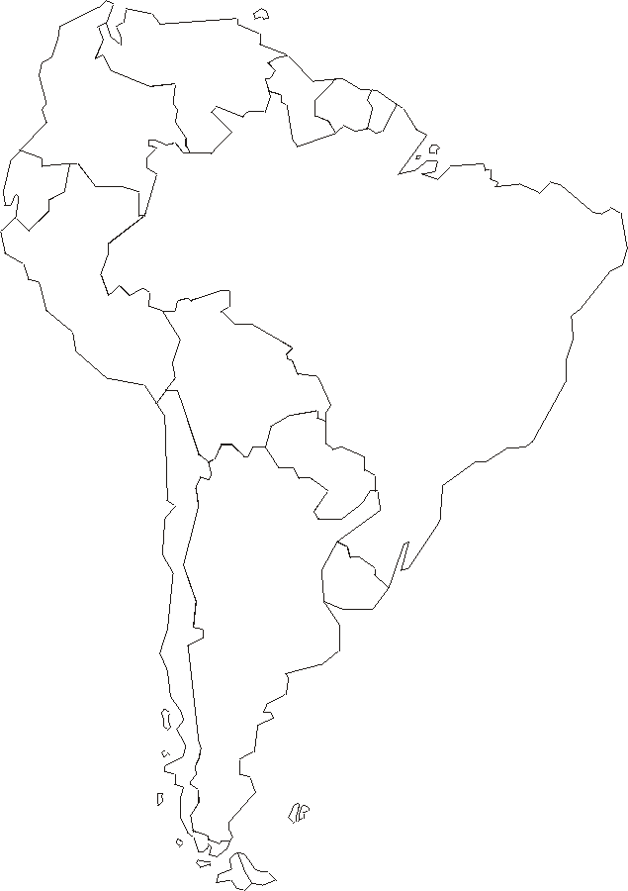

**South America**

**Central America**

**Central America**

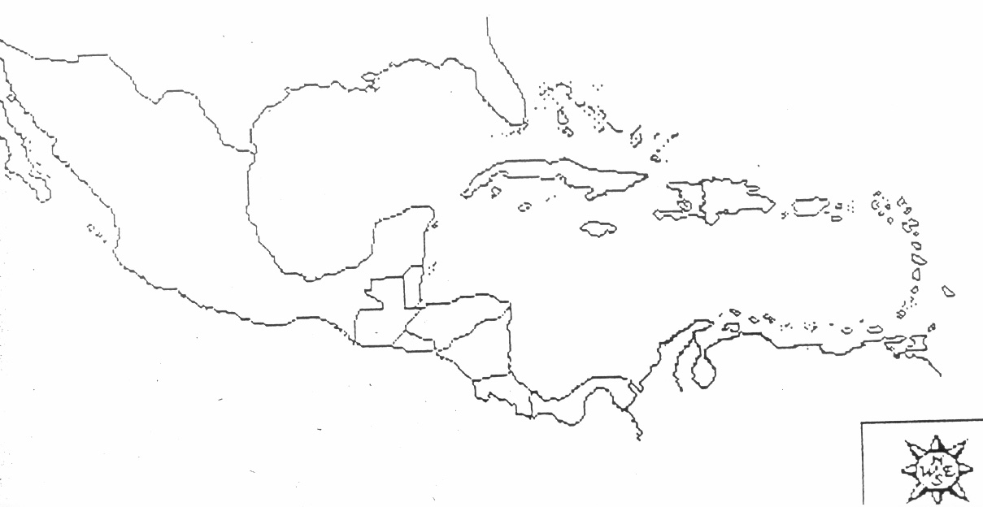

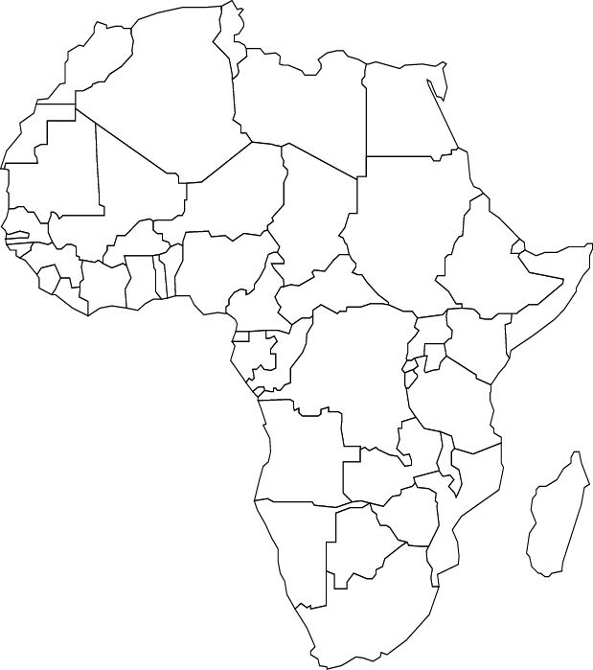

**Africa**

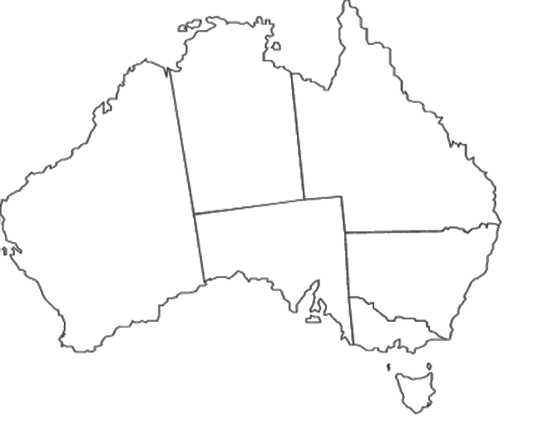

**Australia**

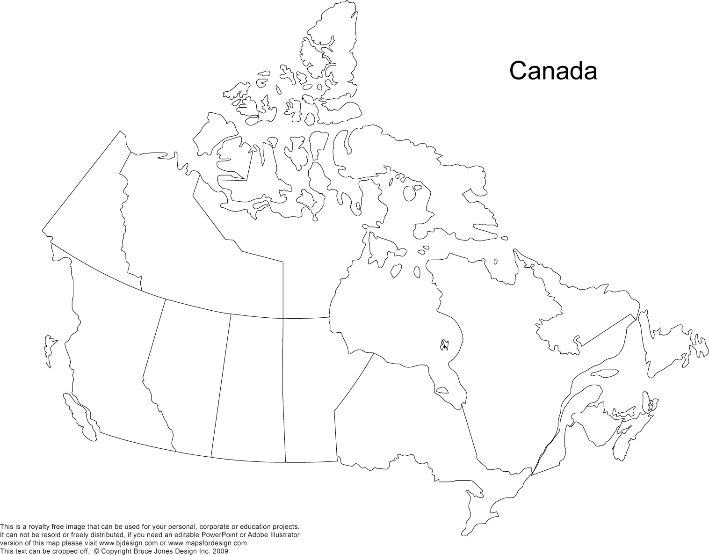**Canada**