World Civ.: Geography Lesson 1 Name: ____________________________Hour:________
- Equator: ______________________________________________________________________________
Why is the Equator the hottest part of the earth? __________________________________________________
_________________________________________________________________________________________
- Prime Meridian: _________________________________________________________________________
- Latitude: _______________________________________________________________________________
- Longitude: _____________________________________________________________________________
- Places that have the same ___________________________________will be in the same time zone.
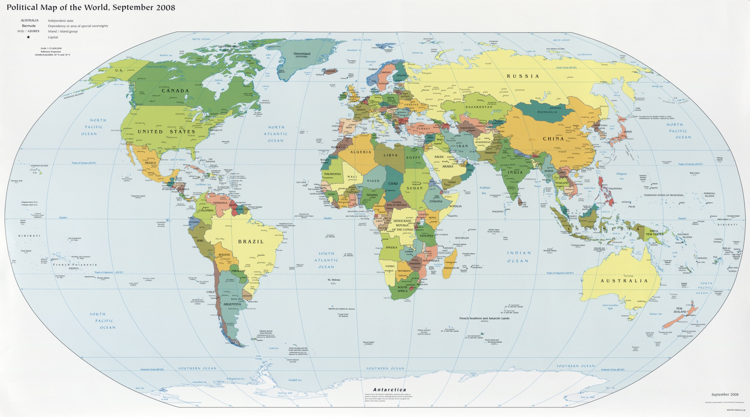____________________________map
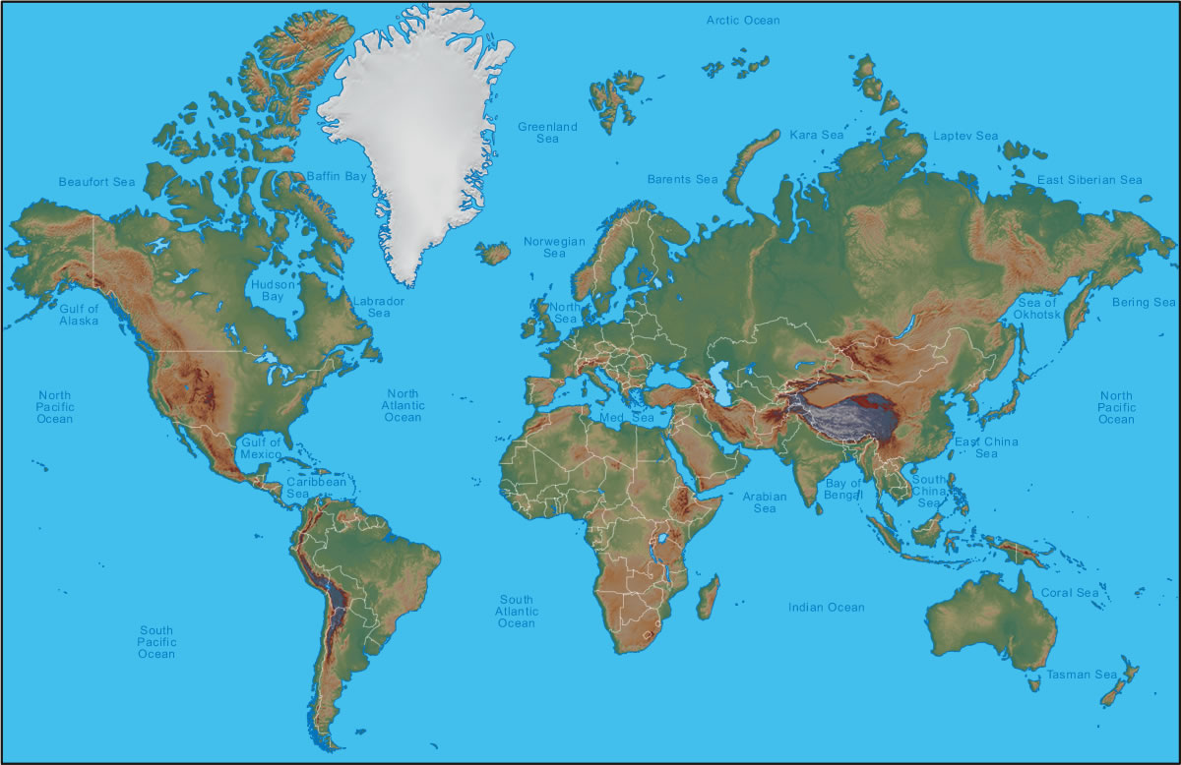_____________________________map

