Chapter 30 Post-War Map Name: _______________________________
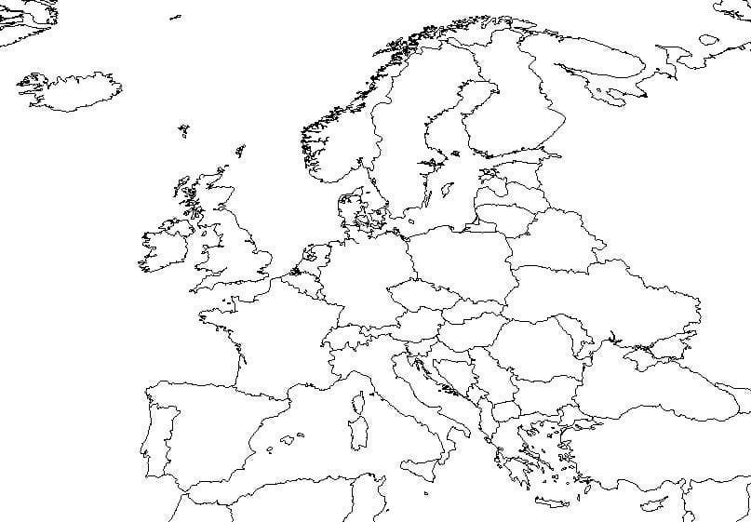
Use the map on p. 994 to color and label the division of Germany as well as the countries (and years) which fell under Soviet control (Don’t forget the Iron Curtain!)

Chapter 30 Key Questions
- How did the events at the close of World War II contribute to the emergence of the Cold War, and how did the U.S. –Soviet rivalry affect the European continent?

- Why did Western Europe recover so successfully, and what were the sources of postwar stability?

- What was the pattern of postwar rebuilding and development in the Soviet Union and communist Eastern Europe?

- What circumstances led to postwar colonial independence movements and how did the Cold War influence this process?

