The Protestant Reformation Name: ____________________
Three Disorders of the Catholic Church
1._____________________– non-practitioners of celibacy; drunkenness, gambling, etc
2. _____________________– uneducated, could not read
3. pluralism / absenteeism – holding ___________ _____________________at once, collecting __________________for all, and being absent from parishes/jobs.
Money Problems
- The Church became increasingly ___________________and interested in maintaining wealth.
- Donations and church taxes were not enough to pay for their luxurious lifestyles
__________________________= Church pardons
  - Sold for________________ (fundraising)
  - Took the place of good works for forgiveness of sin
  - People believed they were ____________________________entrance into heaven
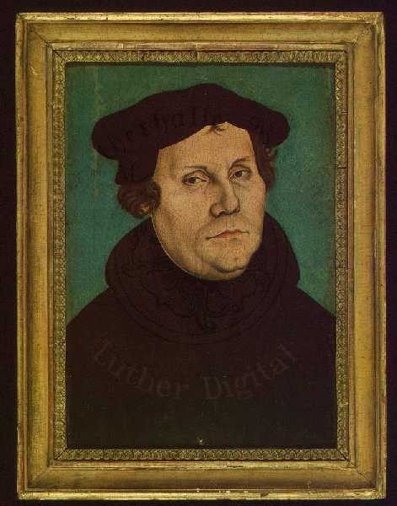
  - Began as reward for service in the ________________________
Martin Luther
- German _________________and professor
- Studied Bible to ____________________indulgences, found no support
- Grew tired of Catholic church
- October 31, 1517 - He posts the 95 theses on a church door in Wittenberg, Germany
Luther’s Opinions
- The_______________ is the only source of truth.
- People can read and understand the Bible _______________________.
- _______________________________comes _________________through __________________in Christ.

Luther Excommunicated
- In Luther’s view, faith alone could bring you to salvation. He refused to stop spreading his ideas.
- Unable to accept this, the Church excommunicated him.
- ____________________ (the Holy Roman Emperor) hoped to change his mind (wanted to preserve the empire through the ___________________of Catholicism). He summoned him before the imperial ____________(legislative assembly).
- The Diet of Worms declared him an outlaw and ordered all his works be _________________.
- Luther went into _____________________until 1522. He was sheltered by the Duke of Saxony.
Revolts in Germany
- Luther urges German __________________to _________________against HRE; princes use Protestantism as justification for rebellion against HRE
- HRE Charles V uses military measures
- Turns on Protestant German princes
- Charles ultimately had no help from ______________________princes
Response to Protests
- Charles needs the support of all of his princes to help in the fight against the ______________________who invade Vienna, Austria in 1529.
- In 1530, Charles V orders all princes to imperial _______________in Augsburg
  - People must revert back to ___________________________
  - Church will get land back
  - This is not ultimately obeyed
- In____________, Charles gives in and grants the_________________________________– “he who owns lands determines religion”

