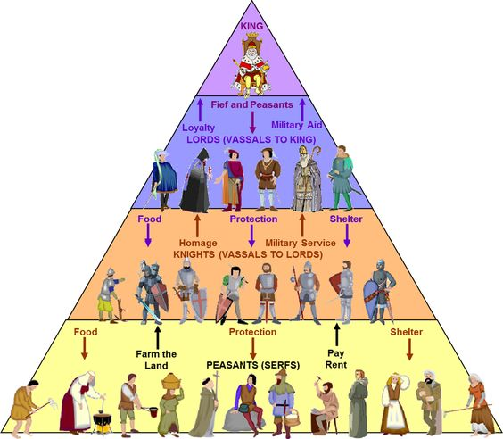
Document 1: Feudalism

Document 2: The Crusades

Two Sides in a Crusade
In 1095, Pope Urban II decided that Europe's kingdoms should help the Byzantine emperor. The Byzantine Empire had faced many invasions. Now the Seljuk Turks were a strong force on the Byzantine borders. Speaking to a group of nobles, Pope Urban II called for all Christians to take up arms and take control of Jerusalem and the Holy Land. The Pope's speech was witnessed and recorded by a nobleman named Fulcher of Chartres.
Many European men, women, and children joined the Crusades and fought in the Middle East. In 1099 they took Jerusalem. Wars continued in the region for many years. In 1187, the Muslim leader Saladin prepared to try to take Jerusalem back from the Christians.
Read the excerpt from Fulcher of Chartres' report of Pope Urban's speech. Then read Saladin's feelings about Jerusalem. Use the information in the speeches to help you answer the questions.
Fulcher of Chartres
"Although, O sons of God, you have promised more firmly than ever to keep the peace among yourselves and to preserve the rights of the church, there remains still an important work for you to do. . . . For your brethren who live in the east are in urgent need of your help, and you must hasten to give them the aid which has often been promised them. For, as the most of you have heard, the Turks and Arabs have attacked them and have conquered the territory of Romania [the Byzantine Empire]. . . . They have occupied more and more of the lands of those Christians, and have overcome them in seven battles. They have killed and captured many, and have destroyed the churches and devastated the empire. If you permit them to continue thus for awhile with impurity, the faithful of God will be much more widely attacked by them. On this account I, or rather the Lord, beseech you as Christ's heralds to publish this everywhere and to persuade all people of whatever rank, foot-soldiers and knights, poor and rich, to carry aid promptly to those Christians and to destroy that . . . race from the lands of our friends. I say this to those who are present, it is meant also for those who are absent. Moreover, Christ commands it. All who die by the way, whether by land or by sea, or in battle against the [Muslims}, shall have immediate remission of sins. This I grant them through the power of God with which I am invested. . . . "
The Words of Saladin
"If God blesses us by enabling us to drive His enemies out of Jerusalem, how fortunate and happy we would be! For Jerusalem has been controlled by the enemy for ninety-one years, during which time God has received nothing from us here in the way of adoration. At the same time, the zeal of the Muslim rulers to deliver it languished. Time passed, and so did many [in different] generations, while the Franks succeeded in rooting themselves strongly there. Now God has reserved the merit of its recovery for one house, the house of the sons of Ayyub [Saladin's family], in order to unite all hearts in appreciation of its members."

Document 2: The Crusades

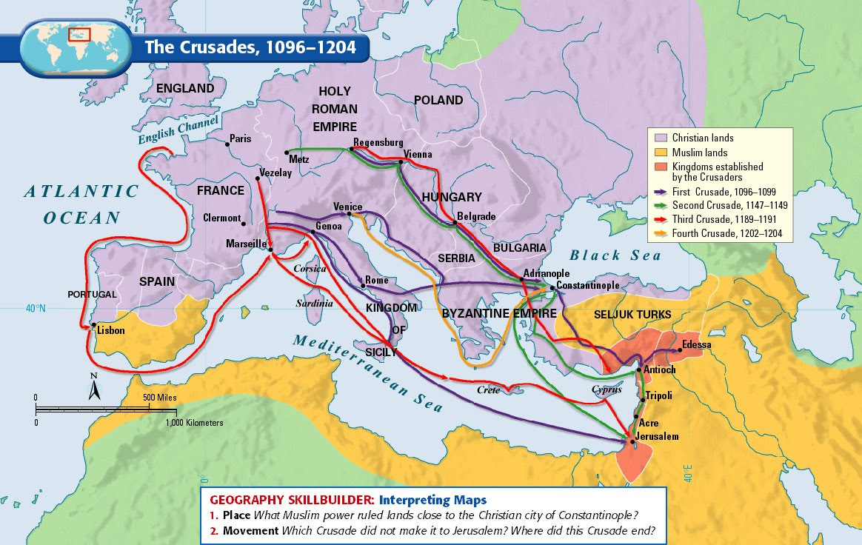

Document 3: The Black Plague

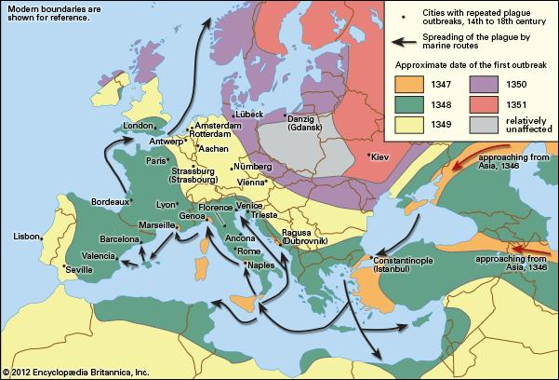

Document 3: The Black Plague

Jean de Venette’s On the Progress of the Black Death
In A.D. 1348, the people of Florence and of almost the whole world were struck by a blow other than war. For in addition to the famine . . . and to the wars . . . pestilence and its attendant tribulations appeared again in various parts of the world. In the month of August, 1348, after Vespers when the sun was beginning to set, a big and very bright star appeared above Paris, toward the west. It did not seem, as stars usually do, to be very high above our hemisphere but rather very near. As the sun set and night came on, this star did not seem to me or to many other friars who were watching it to move from one place. At length, when night had come, this big star, to the amazement of all of us who were watching, broke into many different rays and, as it shed these rays over Paris toward the east, totally disappeared and was completely annihilated. Whether it was a comet or not, whether it was composed of airy exhalations and was finally resolved into vapor, I leave to the decision of astronomers. It is, however, possible that it was a presage of the amazing pestilence to come, which, in fact, followed very shortly in Paris an throughout France and elsewhere, as I shall tell. All this year and the next, the mortality of men and women, of the young even more than of the old, in Paris and in the kingdom of France, and also, it is said, in other parts of the world, was so great that it was almost impossible to bury the dead. People lay ill little more than two or three days and died suddenly, as it were in full health. He who was well one day was dead the next and being carried to his grave. Swellings appeared suddenly in the armpit or in the groin -- in many cases both -- and they were infallible signs of death. This sickness or pestilence was called an epidemic by the doctors. Nothing like the great numbers who died in the years 1348 and 1349 has been heard of or seen of in times past. This plague and disease came fromymaginatione or association and contagion, for if a well man visited the sick he only rarely evaded the risk of death. Wherefore in many towns timid priests withdrew, leaving the exercise of their ministry to such of the religious as were more daring. In many places not two out of twenty remained alive. So high was the mortality at the Hôtel-Dieu in Paris that for a long time, more than five hundred dead were carried daily with great devotion in carts to the cemetery of the Holy Innocents in Paris for burial. A very great number of the saintly sisters of the Hôtel-Dieu who, not fearing to die, nursed the sick in all sweetness and humility, with no thought of honor, a number too often renewed by death, rest in peace with Christ, as we may piously believe.
This plague, it is said, began among the unbelievers, came to Italy, and then crossing the Alps reached Avignon, where it attacked several cardinals and took from them their whole household. Then it spread, unforeseen, to France, through Gascony and Spain, little by little, from town to town, from village to village, from house to house, and finally from person to person. It even crossed over to Germany, though it was not so bad there as with us. During the epidemic, God of His accustomed goodness deigned to grant this grace, that however suddenly men died, almost all awaited death joyfully. Nor was there anyone who died without confessing his sins and receiving the holy viaticum. . . .
Some said that this pestilence was caused by infection of the air and waters, since there was at this time no famine nor lack of food supplies, but on the contrary great abundance. As a result of this theory of infected water and air as the source of the plague the Jews were suddenly and violently charged with infecting wells and water and corrupting the air. The whole world rose up against them cruelly on this account. In Germany and other parts of the world where Jews lived, they were massacred and slaughtered by Christians, and many thousands were burned everywhere, indiscriminately. The unshaken, if fatuous, constantly of the men and their wives was remarkable. For mothers hurled their children first into the fire that they might not be baptized and then leaped in after them to burn with their husbands and children. It is said that many bad Christians were found who in like manner put poison into wells. But in truth, such poisonings, granted that they actually were perpetrated, could not have caused so great a plague nor have infected so many people. There were other causes; for example, the will of God and the corrupt humors and evil inherent in air and earth. Perhaps the poisonings, if they actually took place in some localities, reinforced these causes. The plague lasted in France for the greater part of the years 1348 and 1349 and then ceased. Many country villages and many houses in good towns remained empty and deserted. Many houses, including some splendid dwellings, very soon fell into ruins. Even in Paris several houses were thus ruined, though fewer here than elsewhere.
After this cessation of the epidemic, pestilence, or plague, the men and women who survived married each other. There was no sterility among the women, but on the contrary fertility beyond the ordinary. Pregnant women were seen on every side. . . . But woe is me! the world was not changed for the better but for the worse by this renewal of population. For men were more avaricious and grasping than before, even though they had far greater possessions. They were more covetous and disturbed each other more frequently with suits, brawls, disputes, and pleas. Nor by the mortality resulting from this terrible plague inflicted by God was peace between kings and lords established. On the contrary, the enemies of the king of France and of the Church or stronger and wickeder than before and stirred up wars on sea and on land. Greater evils than before [swarmed] everywhere in the world. And this fact was very remarkable. Although there was an abundance of all goods, yet everything was twice as dear, whether it were utensils, victuals, or merchandise, hired helpers or peasants and serfs, except for some hereditary domains which remained abundantly stocked with everything. Charity began to cool, and iniquity with ignorance and stand to abound, for a few could be found in the good towns and castles who knew how or were willing to instruct children in the rudiments of grammar.

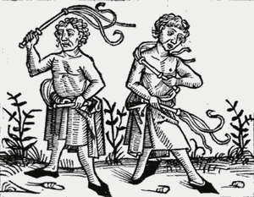
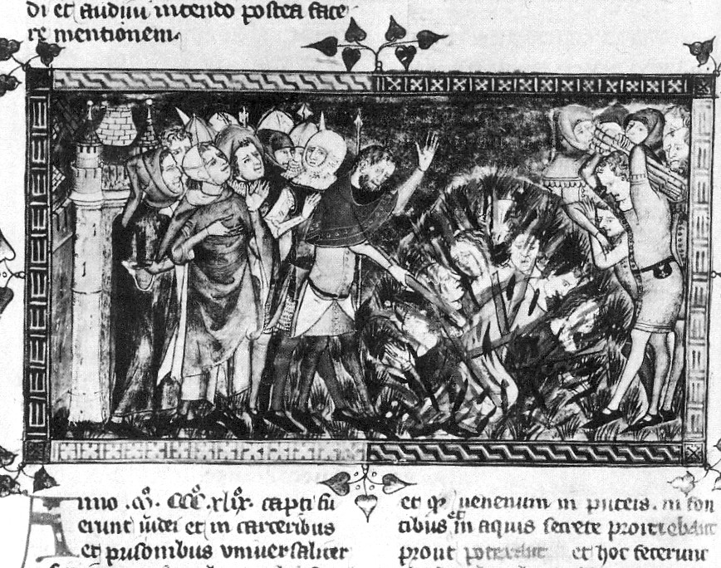
Document A

Document B

Document 4: Medieval Society – “Life and Times in the Year 999”
If you had been alive in Europe in 999 A.D. -- on the eve of the last millennium -- you'd have inhabited a world only barely recognizable to modern Americans. The grand, sophisticated cultures and large urban centers were elsewhere: China, which boasted perhaps the greatest city in the world, the imperial capital of Kaifeng; the Byzantine Empire; and the vast extent of Islam, the most widely dispersed civilization on Earth at the time.
Since the fall of the Roman Empire five centuries earlier, Europe had become a comparatively poor, backward and intensely rural place. Although there may have been 70 million people from Scandinavia to Greece (far fewer than present-day Germany alone), more than 90 percent of them lived on the land, and a really big city had 10,000 or 20,000 inhabitants. Much of Europe's population was clustered from what now is Holland, down through France and into Italy, and most people lived near the coast.
Without the vanished Roman legions (powered by slave labor) to maintain roads, cities and fortifications, travel had become extremely difficult. Maps were practically unknown, and once dependable routes had fallen into ruin. Some lords maintained the roads across their holdings and charged a toll to use them. But there were so few travelers that it wasn't cost-effective.
In the late 10th century, average life expectancy was about 30, largely because the infant mortality rate was 40 percent.
A male who survived his teens might live to a ripe old 47 or so; women died at about 44. This pattern agreed with Aristotle's pronouncement that men, being the more perfect representation of human beings, should naturally live longer. Things began to change in the later Middle Ages, and by the Renaissance, women were outliving men, as they do today.
Nonetheless, life was dismayingly short by today's standards. In 999, even the average age of kings at death was well below 50. Most children would not have known their grandparents.
The most visible difference among social classes was in clothing, a practice that would be formalized in the 12th century in the form of dress codes for different groups. "Peasants are not allowed to wear any colors other than black or gray," intoned one Germanic edict about 1150, and "seven yards of linen for shirts and pants are adequate."
In 999, the average peasant would have worn a knee-length tunic or smock with a shirt beneath and cloth wrapped around the legs in lieu of trousers. The better classes wore pants, but underpants were extremely rare in any social class before the 13th century.
Shoes were made from a single piece of leather stitched together at the top. Except for special occasions, nobles wore a more costly and colorful variation on these same themes.
In most parts of Europe in 999, one became a legal adult at 12. If you lived in an area still following old German customs, you only had one name -- a practice that has made it difficult for historians to trace family lines in many places.
Marriage, widespread even among enslaved serfs, was allowed as early as 14 for boys and 12 for girls but averaged about 20 to 24 for men and 14 to 16 or later for women. A restricted or fat-poor diet delays the onset of menstruation, which probably arrived about age 15 for peasant girls in many 10th-century cultures. So it is not surprising that average age at marriage was considerably older than the official ecclesiastical minimum.
The wedding ceremony, though usually blessed by a priest, would have been local and secular. The church didn't have formal marriage rites until the 12th century. Divorce was correspondingly uncomplicated in 999.
Standing firm in the uncertainty of life in 999 was an institution that gave life meaning and imposed order -- the Christian church, the most influential force in Europe.
From birth to death, the church permeated almost every aspect of life. With spiritual and temporal powers closely intertwined, it offered sustenance for the soul and served as a powerful civic authority.
As Europe's wealthiest organization and the receptacle for all of its knowledge and learning, the church was in a unique position to fulfill its multiple roles.
The relationship between papacy and empire had been strained for centuries, each side claiming ultimate authority. The tenuous partnership was rooted in an ideal first propagated by Charlemagne. Under that, the Christian empire of the West upheld and defended the Roman church for the greater glory of God.
The Islamic and Asian Empires
The spread of Islam was rapid after its establishment in the 7th century, and Muslim civilization carried with it a vast amount of learning retained from Hellenic science, imported from Hindu sources or pioneered by Arab researchers.
The physicist Alhazen (965-1039) advanced knowledge of optics, mirrors and lenses, and others extended the work of al-Khwarizmi, the 9th century mathematician from whose name comes our word algorithm and from whose work comes the term algebra.
Hindu mathematicians had introduced the notion of zero, as well as a decimal system in which the value of each number was determined by its position. Both are familiar now. But they would transform science in Europe, which remained stuck with unwieldly Roman numerals until the Arabic-Hindu "positional" system took over in the 13th century.
Chinese scientists also were busily at work, taking detailed astronomical observations, inventing modern paper and gunpowder and exploring the magnetic properties that would lead to the compass, although that device would find perhaps its greatest effect in the West.

