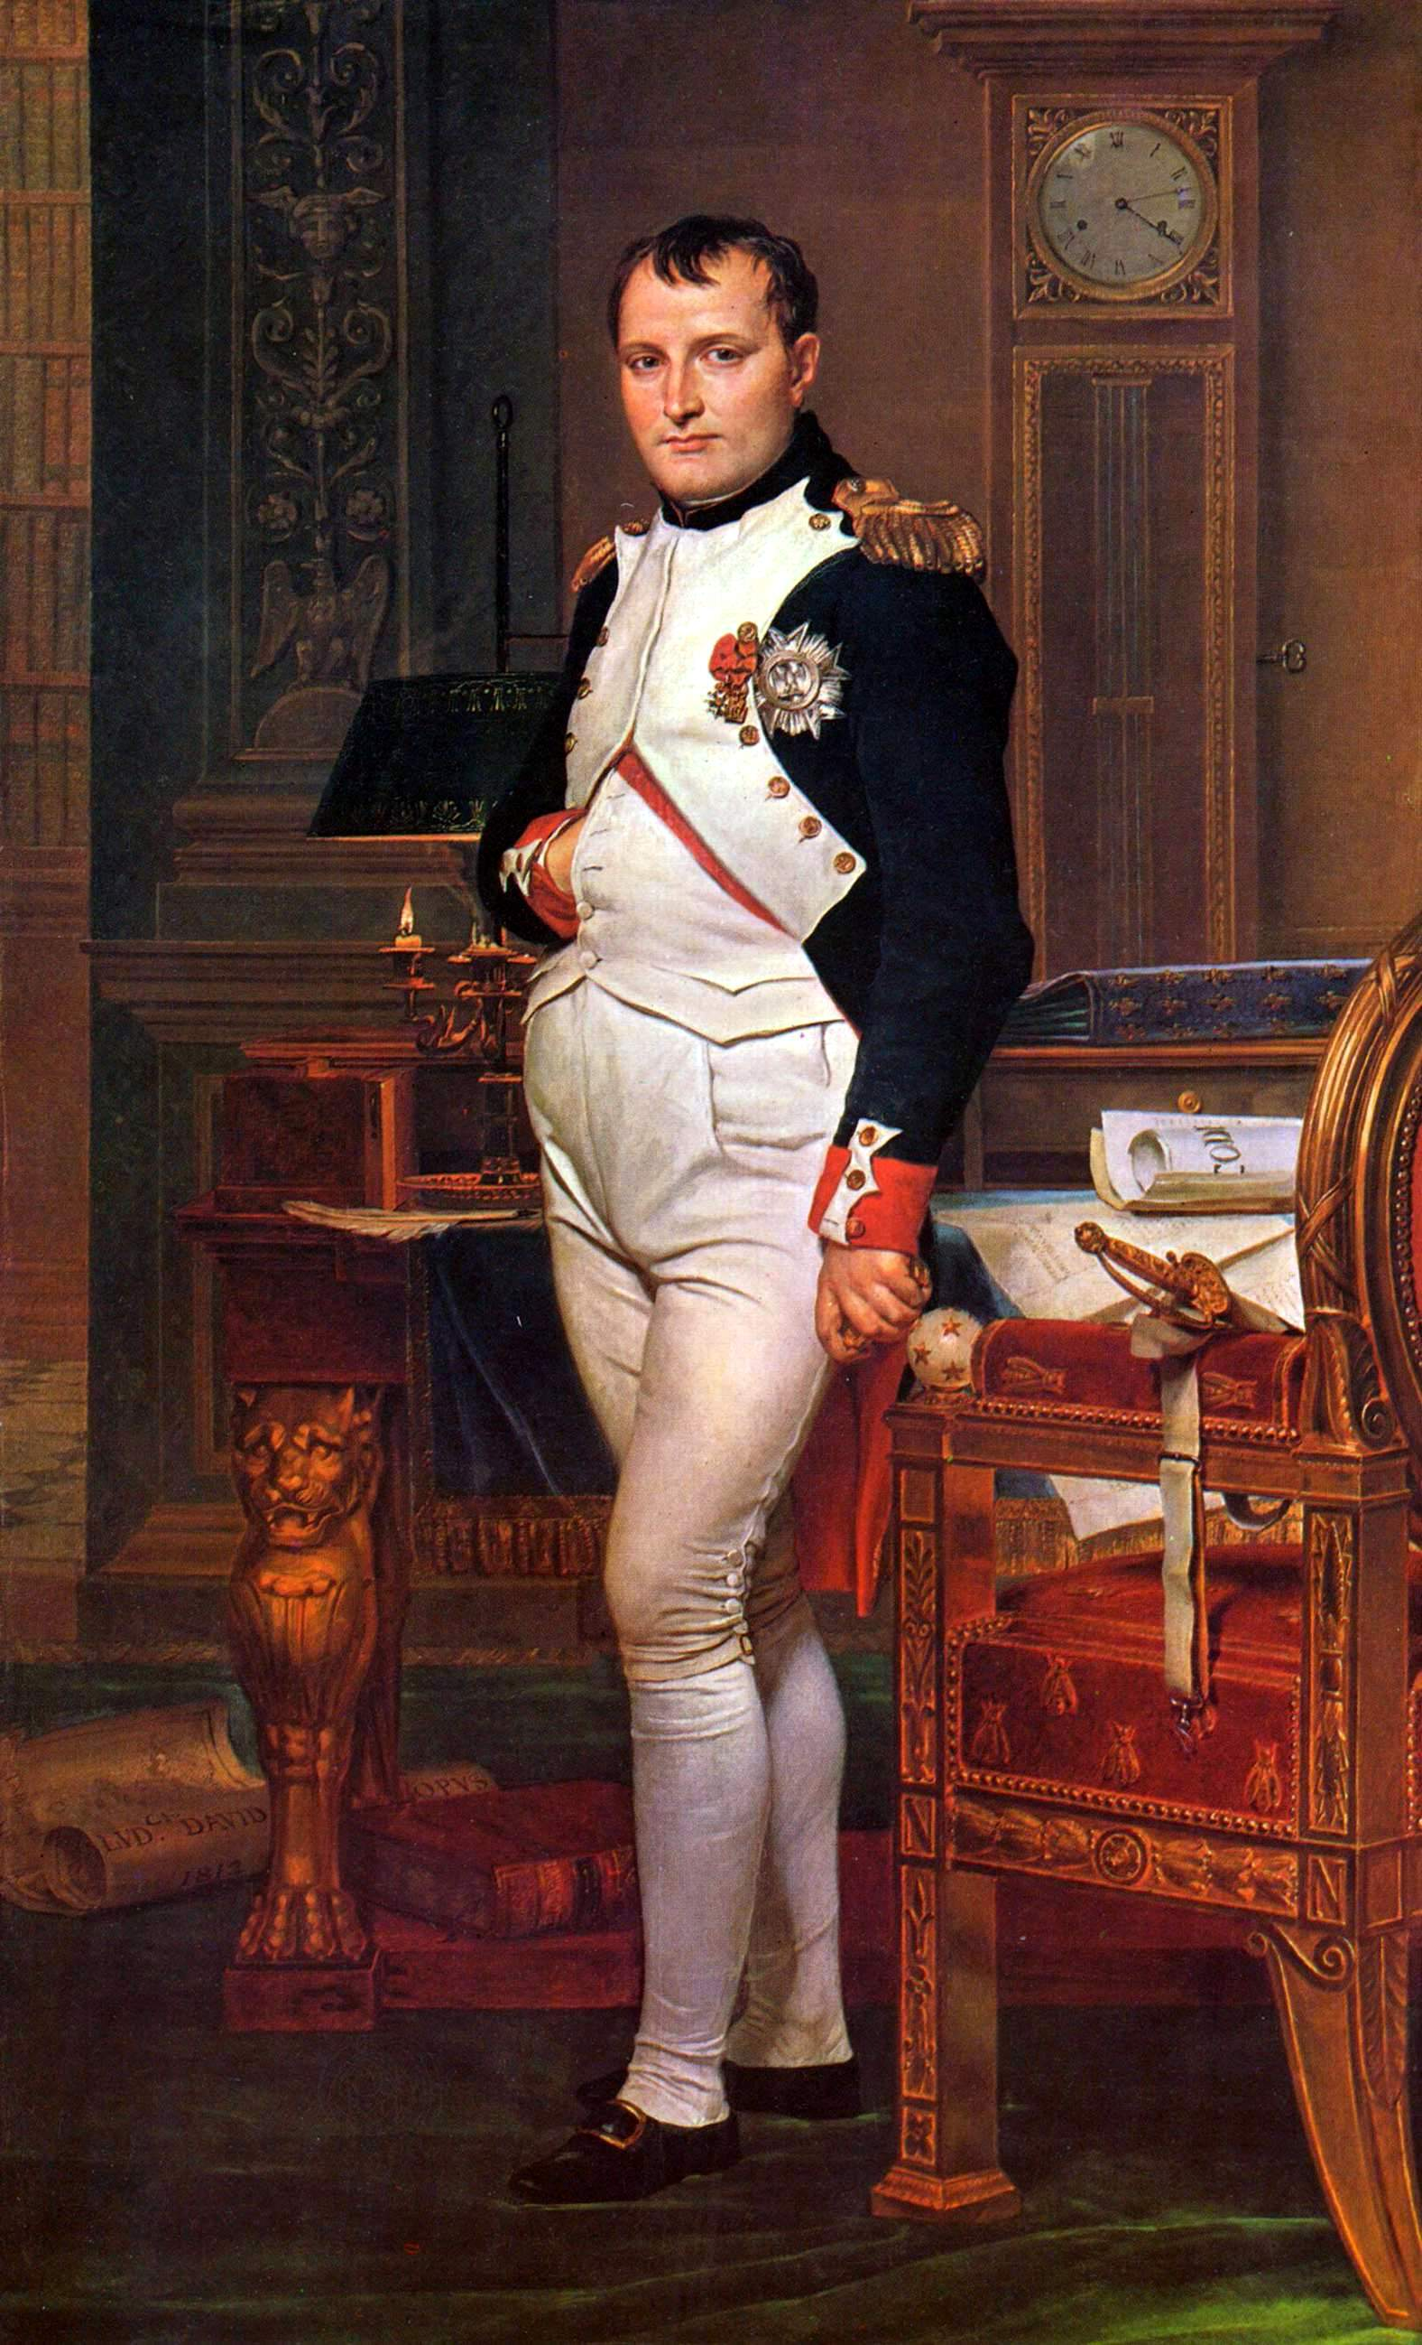
The Emperor Napoleon in his Study at Tuileries, 1812

The Oath of the Horatii, 1794
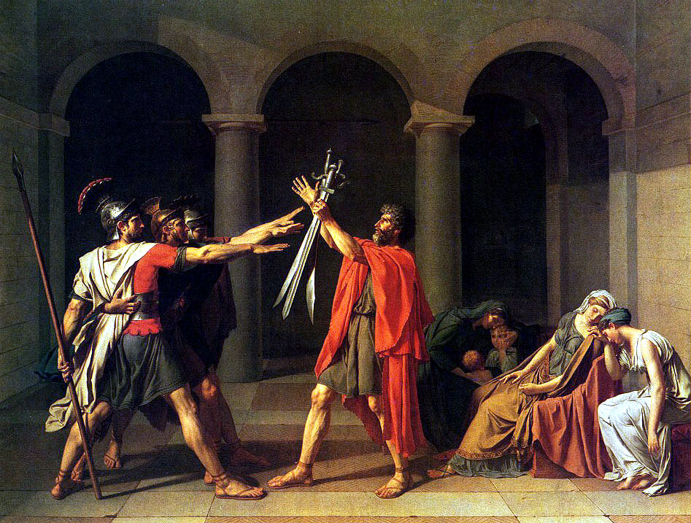
The Lictors Bring Brutus the Bodies of his Sons, 1789
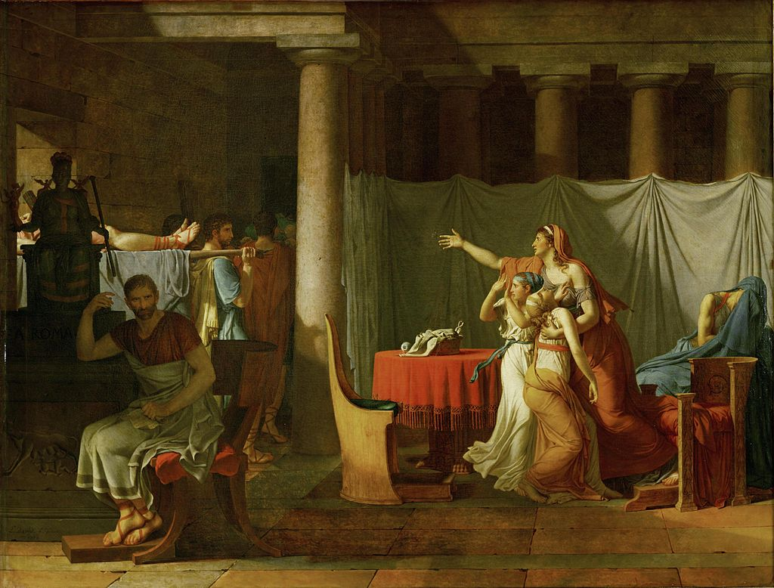
Self Portrait, 1794
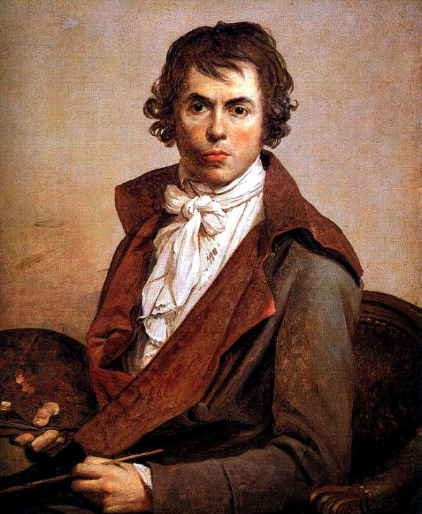
Intervention of the Sabine Women, 1799
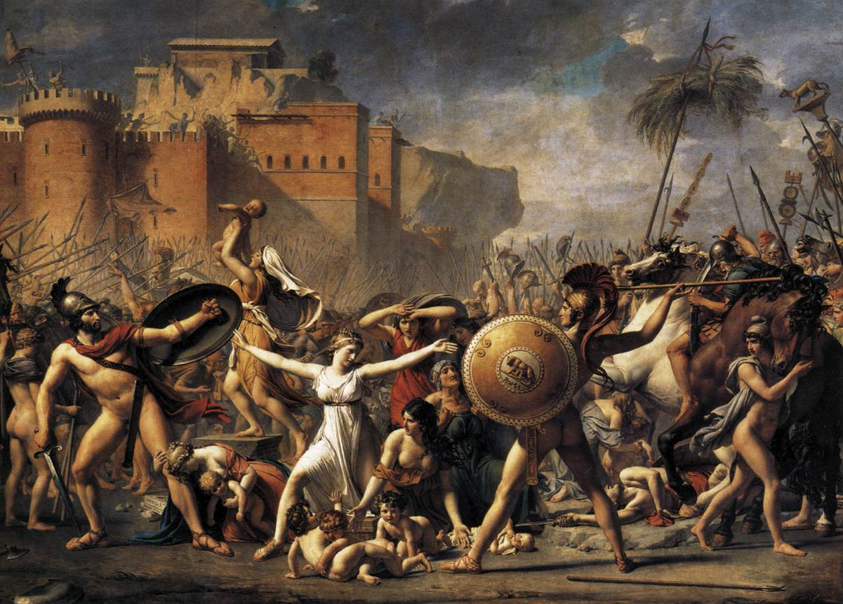

The Death of Socrates, 1787
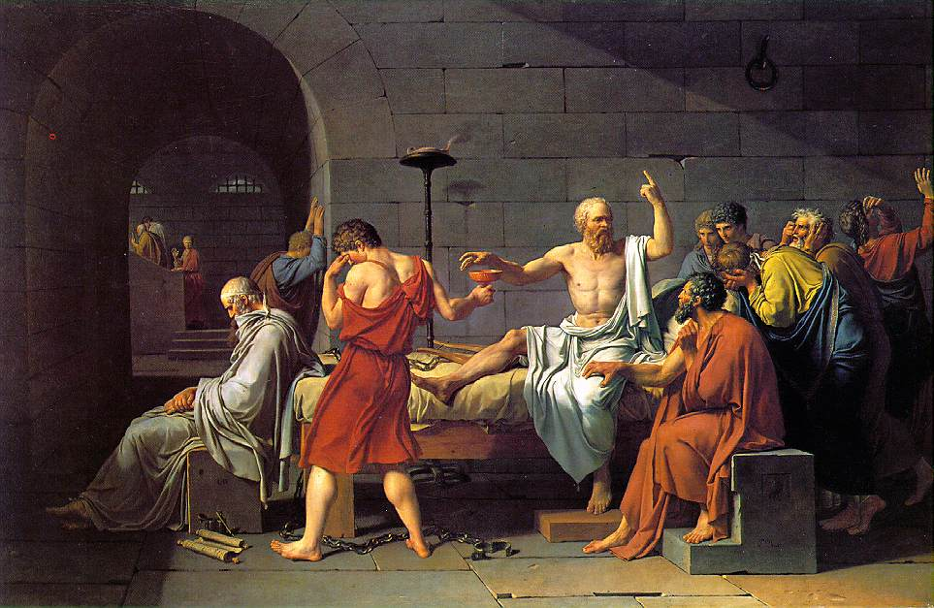

The Coronation of the Emperor Napoleon I in Notre-Dame Cathedral on December 2, 1804 (1805 – 1807)
