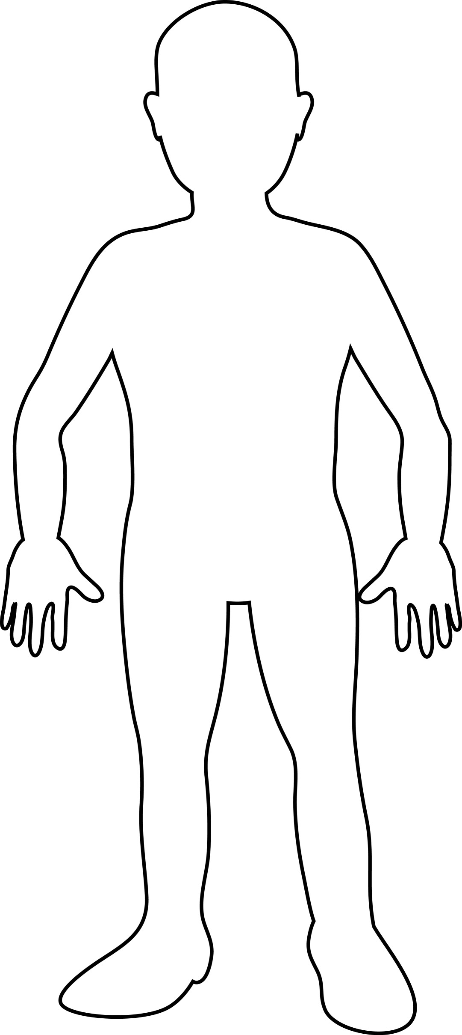
Who am I? ____________________________________________

Middle Ages / Renaissance / Reformation Character map
Name: ____________________________________

Use what you have learned about people in the Middle Ages, Renaissance, and the Reformations to create a character map of a person.
Your options include:

Generic Middle ages person (choose from the feudal system) Generic Renaissance Gentleman or Woman Leonardo Da Vinci Michelangelo Martin Luther Ulrich Zwingli John Calvin German Prince who opposes Charles V Charles V Henry VIII

Must include:
- Physical appearance (clothing style, hair style, physical features, etc) (3 pts)
- At least three objects that relate to their livelihood (6 pts)
- Background / setting reflecting where they lived (3 pts)
- Quote or something he or she would have said (5 pts)
- Color (3 pts)

Total: _____________/20

