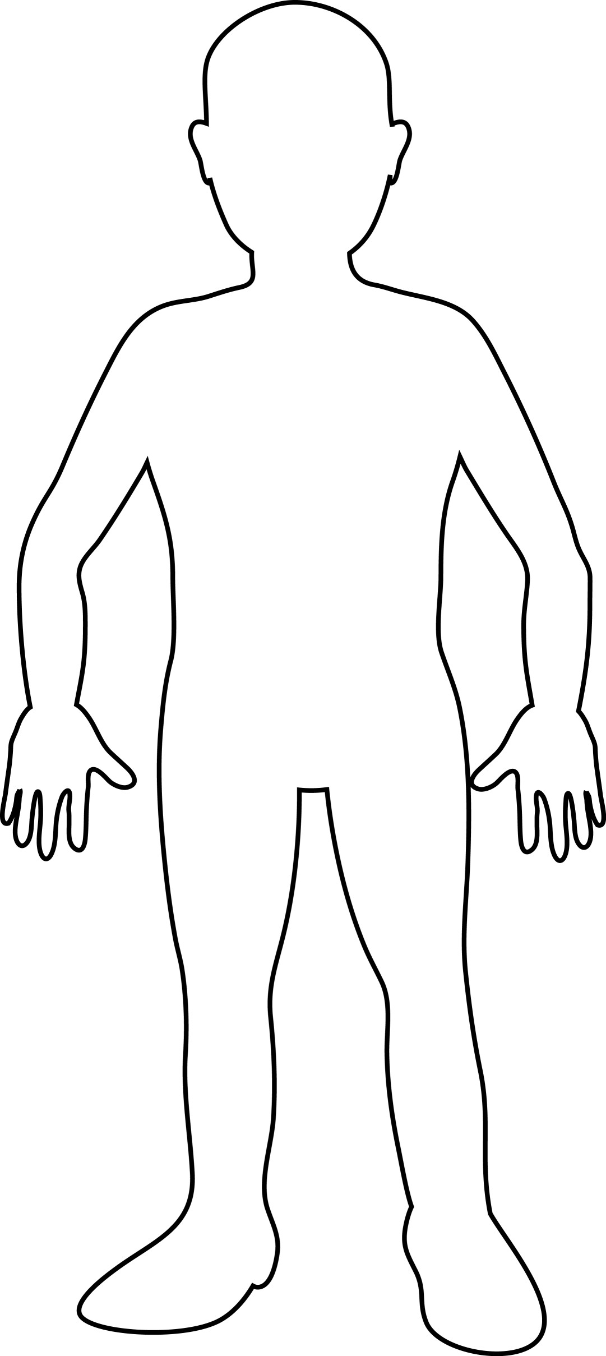

Name: _____________________________________
Chapter 18 – Scientific Revolution & Enlightenment figures
Name: ____________________________________
Use what you have learned about your figure to create a character map of that person.
Must include:

- Physical appearance (clothing style, hair style, physical features, etc) (3 pts)
- At least three objects that relate to their field of study (6 pts)
- Background / setting reflecting where they lived (3 pts)
- Quote or something he or she would have said (5 pts)
- Color (3 pts)

Total: _____________/20

