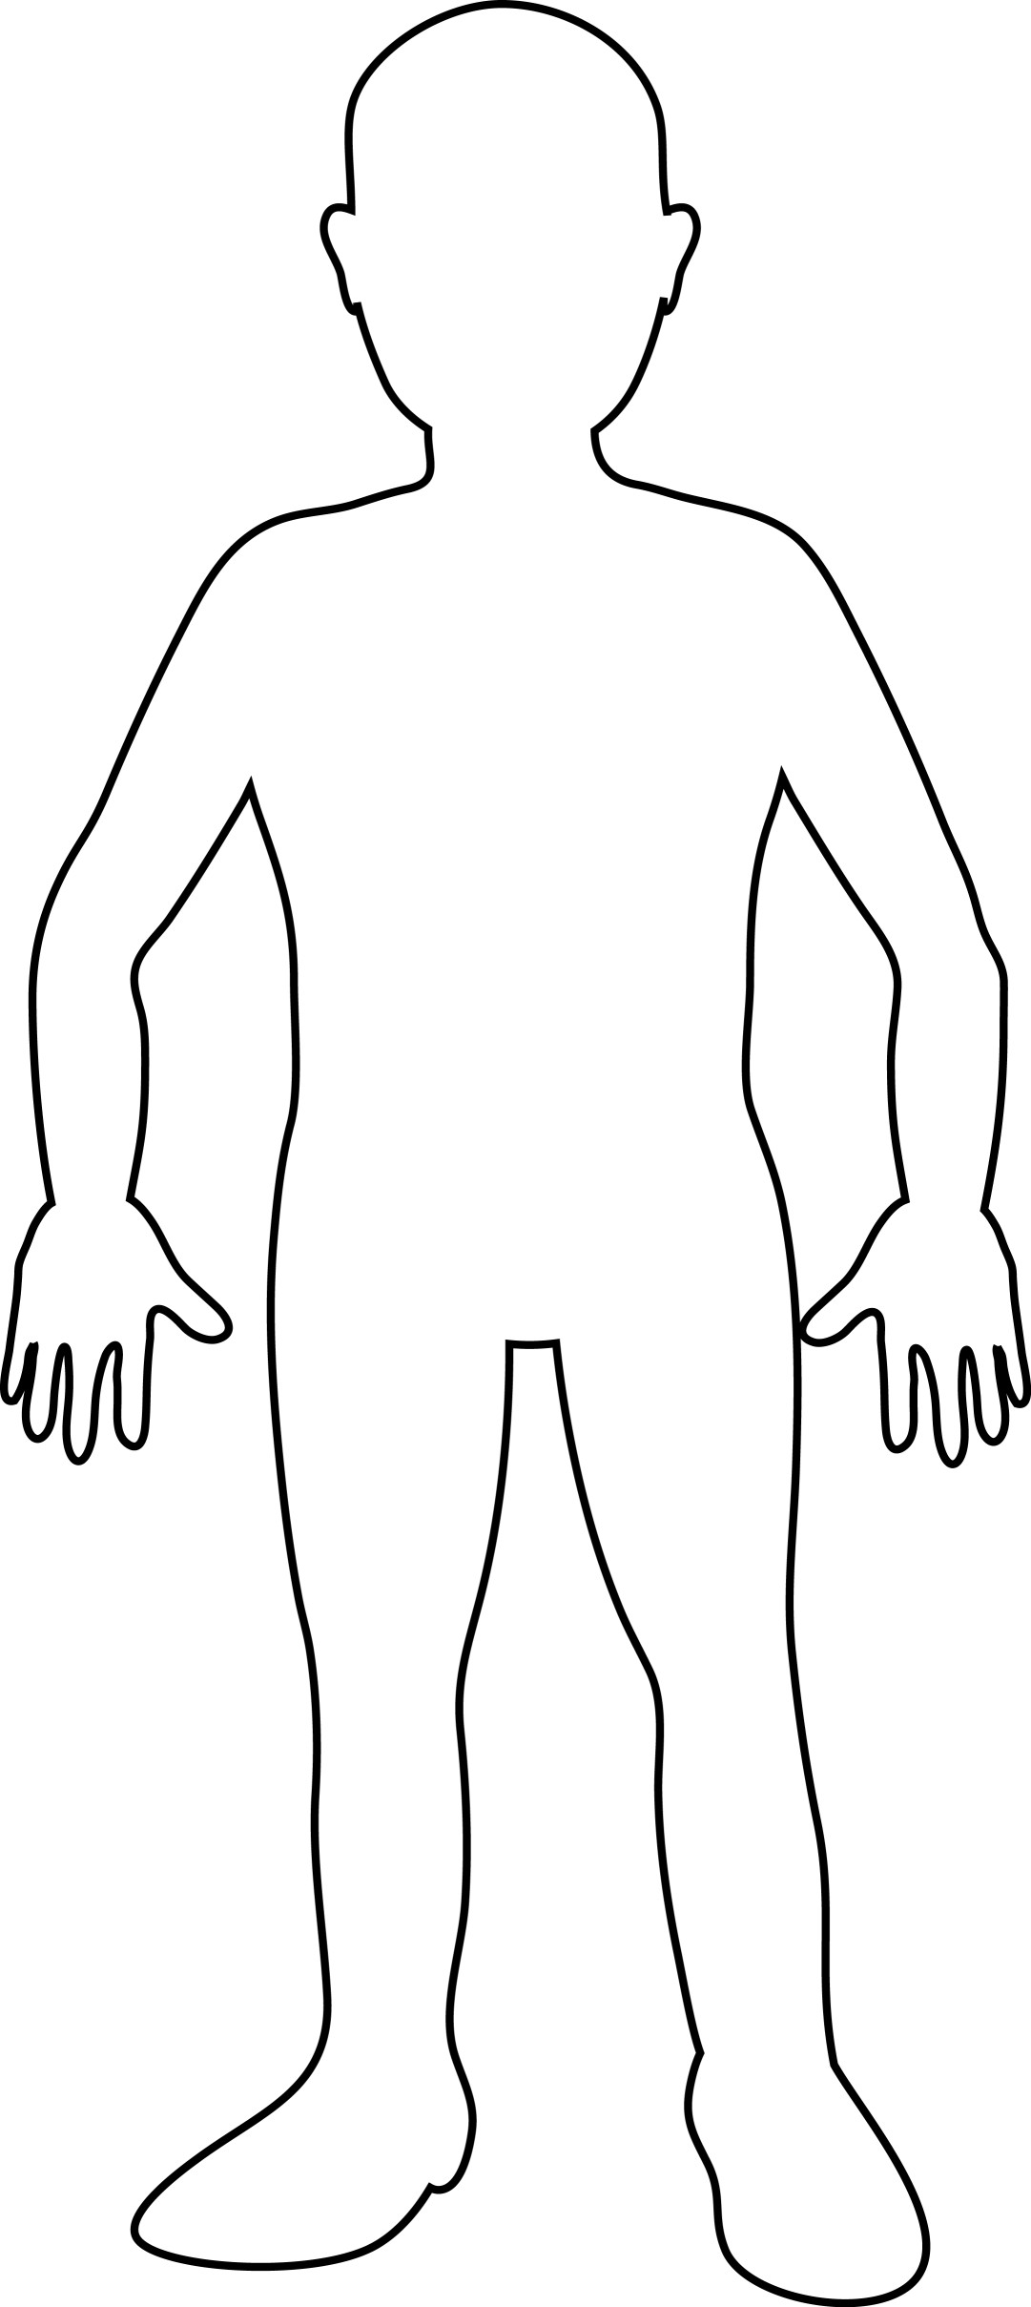
Who am I? ____________________________________________

Absolute Monarchs Character map
Name: ____________________________________

Use what you have learned about Absolute monarchs in the late 16th-early 18th centuries to create a character map of a person.
Your options include:

- Elizabeth I
- Phillip II
- Louis XIV
- Frederick William I (The Soldier King)
- Frederick II (The Great)
- Peter the Great

Must include:
- Physical appearance (clothing style, hair style, physical features, etc) (3 pts)
- At least three objects that relate to their livelihood (6 pts)
- Background / setting reflecting where they lived (5 pts)
- Quote or something he or she would have said (5 pts)
- Color (1 pts)

Total: _____________/20

